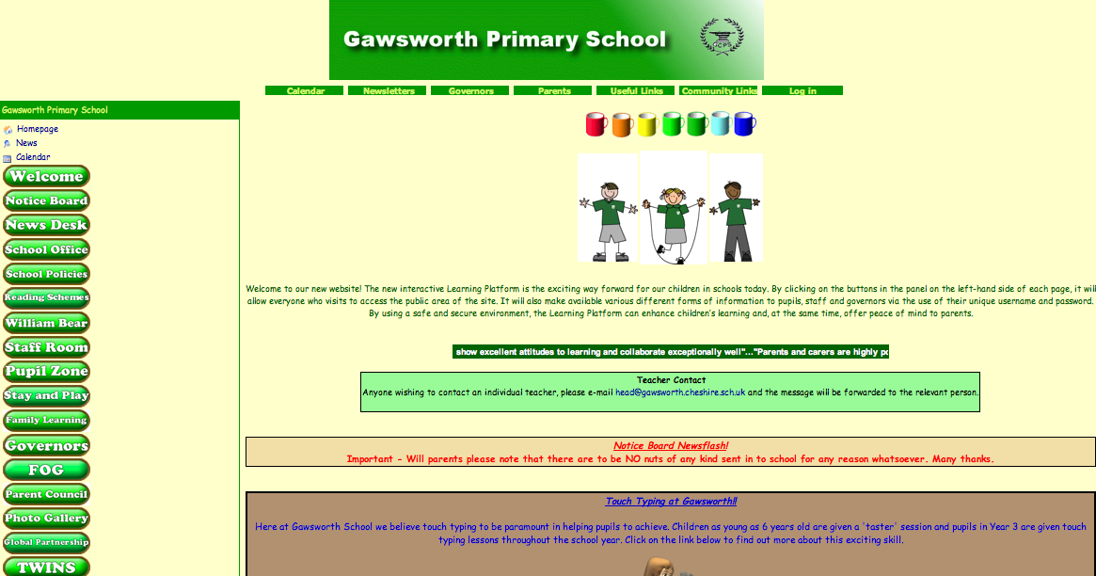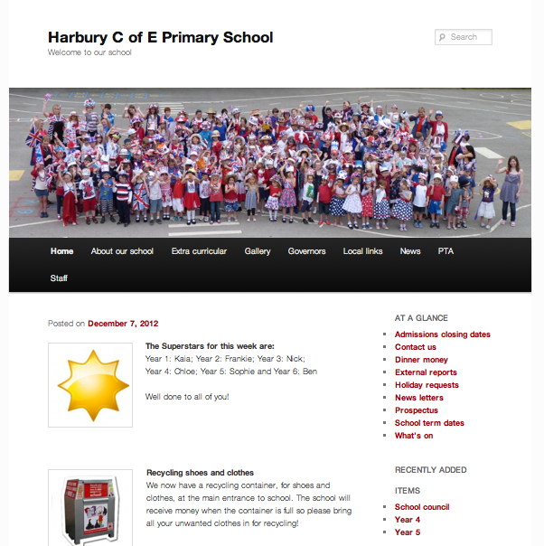When researching into what I think makes a good website and which ones I think lack in good web design I think the following site sums up quite well what I feel a primary school website should be like. The [Harbury Primary School](http://www.harburyschool.com/) website is very simplistic and easy to navigate around. Children start primary school at the age of 4 and leave when they are 11 and therefore although the site may be aimed at the parents, if the children were to go on the site they need to be able to navigate around it easily. The site is straight to the point and has good structure. On the other hand I have found a primary school website that is more complex and I feel does not come across as good design for a primary school site. This is the site of [Gawsworth Primary School.](http://clc2.uniservity.com/GroupHomePage.asp?GroupId=277257) As you can see from the print screen the site is quite busy and complex. This can be very confusing for the user as it is quite hard to navigate around and find what you are looking for. Although the site is obviously for a primary school due to the choice of images used I think it could have been designed better.

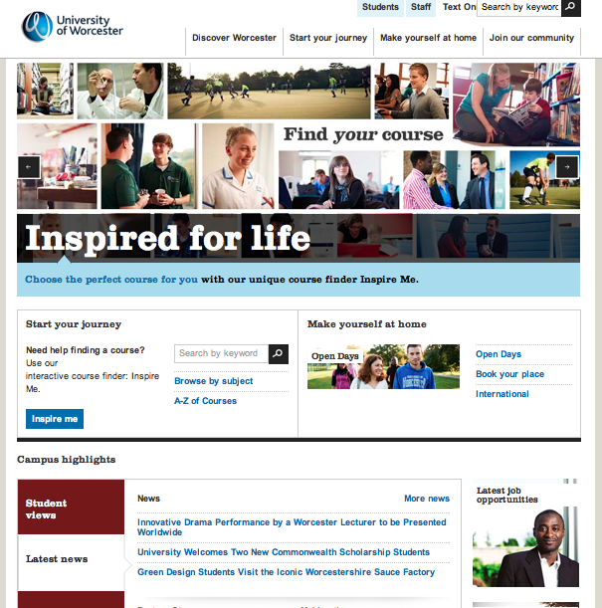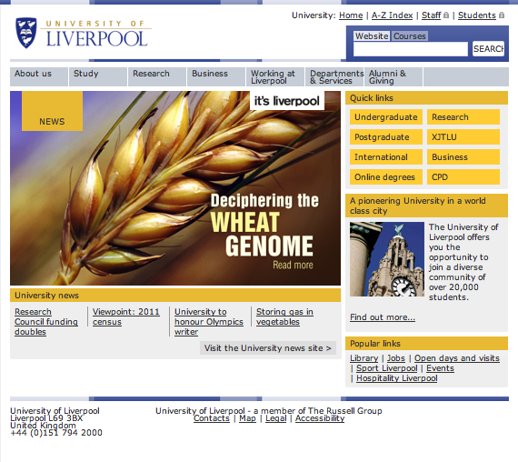Looking at two sites now that are a lot more complex are those of universities. The target audience for these sites are a lot older than that of primary schools and therefore do not need to worry about keeping the interface simplistic. It needs to be more complex and detailed in order to appeal to the right audience. The first site that I have chosen to discuss is that of [Worcester University](http://www.worcester.ac.uk/). This site I feel has a bad web design as it has poor usability, by this I mean that it is hard to find what you are looking for. In comparison to this is the [University of Liverpool](http://www.liv.ac.uk/). This site is straight to the point in a mature way of what it wants the users first impression of the university to be. It has clear clarity of purpose, good structure, and is focused.